**Water Treatment Investigation**

Outcomes: Science Inquiry; Science Understanding: Earth and Space

**Aim: To test the effectiveness of different types materials as filters**

This investigation will involve using different materials for filtering water. The materials we are going to use are kitchen towel, kitchen chux and sponge

**Can you write this as a question to be investigated?**

_____________________________________________________________________________________________________________________________________________________________________________________________________________________

**Hypothesis:**

_______________________________________________________________________

**Apparatus:** Draw a labelled diagram (or series of diagrams) to show how you filtered the polluted water. **Results:**

Write a title for your table.

Write units for headings that need them.

Record your results in the table below.

Title:___________________________________________________________________

|  |  |  |  |  |
| --- | --- | --- | --- | --- |
| Filtering Material | Weight before  (grams) | Weight after  (grams) | Weight change  (grams) | Appearance of filtrate |
| Tea towel |  |  |  |  |
| Kitchen chux |  |  |  |  |
| sponge |  |  |  |  |

**Discussion:**

What was your independent (changed) variable?

_______________________________________________________________________

What was your dependent (measured result) variable?

_______________________________________________________________________

What were three controlled (kept the same) variables?

_____________________________________________________________________________________________________________________________________________________________________________________________________________________

Discussion:

___________________________________________________________________________________________________________________________________________________________________________________________________________________________________________________________________________________________

Did you have any difficulties or problems with your experiment? (With your method)

_____________________________________________________________________________________________________________________________________________________________________________________________________________________

How would you fix this problem if you did this experiment again?

___________________________________________________________________________________________________________________________________________________________________________________________________________________________________________________________________________________________________________________________________________________________________

**Conclusion:**

What was the overall result?

_______________________________________________________________________

______________________________________________________________________________________________________________________________________________

Was your prediction correct? Explain

Draw a graph

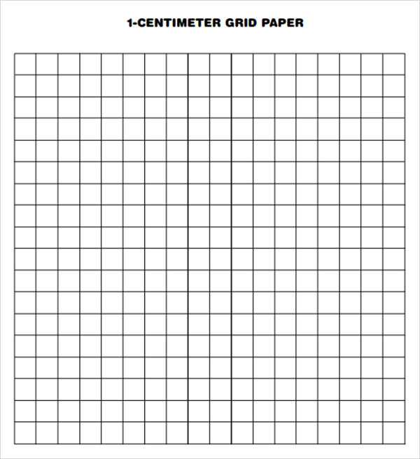

|  |  |  |  |
| --- | --- | --- | --- |
|  |  | Mark Allocation | Mark |
| Questions | * Writes a question which refers to independent and dependent variables | 1 |  |
| Prediction | * Writes a prediction as a sentence | 1 |  |
| Diagram(s) | * Diagram(s) shows all equipment, including sizes or types * Diagram(s) indicate method for weight measurement * Diagram is neat, in pencil, suitable size and stylised and two dimensional | 3 |  |
| Results | * Table title relates independent and dependent variables * Calculations include units where appropriate * Describes the appearance of filtrate | 3 |  |
| Graph | * Graph title relates variables * Graph type is appropriate * Axis are correct, labelled * Graph is appropriate size and scale | 4 |  |
| Variables | * Independent variable is identified * Dependant variable is identified * 1-3 controlled variables identified | 3 |  |
| Discussion | * Mentions about appearance and filtrate * Difficulties or sources of error identified * Suggestion for improvement | 3 |  |
| Conclusion | * Summary of findings * Prediction correct or not | 2 |  |
|  |  | Total  /20 |  |